SAVDOER Microsoft Access Database Readme
Disclaimer: These data were compiled for U.S. government use and represent the results of data collection/processing for a specific Department of Defense (DoD) activity. The DoD makes no representation as to the suitability or accuracy of these data for any other purpose and disclaims any liability for errors the data may contain. Please exercise appropriate and professional judgment in the use and interpretation of these data.
The Microsoft Access database consists of six related tables. The structure of the database is summarized in Figure 1. The Master Table contains the bulk of the ground truth data for all data types. The Master Table contains a record for each location at which data were collected and stores each piece of data as a point. Each record is uniquely identified with an ID field. The table field names are specially formatted so the data can be imported into ESRI ArcMap. The database is designed to be used with Microsoft Access 2007 or later. Some of the database functionality will be lost if an older version of Microsoft Access is used.
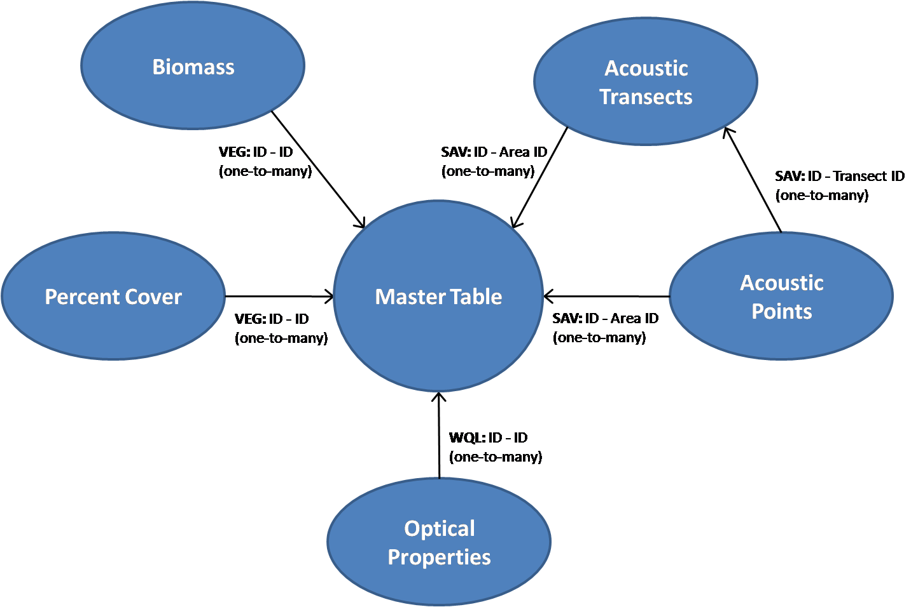
Figure 1 Microsoft Access database table relationships

Table 1 contains the definitions of all of the fields in the Master Table.
Table 1 Master Table field definitions.
Field name | Field definition
ID | Unique 10-digit alpha-numeric key identifying the record. This is the primary key field for the table. It is a variant of the Field_ID, which is the identifier given in the field notes. The Field-ID was not necessarily unique so it was combined with the date, data type, and/or an alphabetic counter to make it unique.
Field_ID | The alpha-numeric ID given by the researchers in the field.
Site | The two-letter site code for the location at which the data were collected. (BB – Buzzards Bay, PH – Plymouth Harbor)
Meas_date | The date the measurement was collected
Meas_time | The 24-hour time at which the measurement was made or the field team arrived at the GPS location. If this field is blank, the time was not recorded.
Type | The three-letter code representing the type of data collected.
Latitude | The latitude of the point in decimal degrees. If this field is blank, the location was not recorded.
Longitude | The longitude of the point in decimal degrees. If this field is blank, the location was not recorded.
Rep | The repetition number if multiple measurements were made of the same cover type. If this field is blank, only one sample of the cover type was made.
Descrip | The text field that contains a description of the measurement point.
Filename | The filename of the data file uploaded into the Attachment field. Note that image filenames are not listed.
Junk | The Junk field is a binary field used to identify data points known to be faulty. This field is only relevant for the ASD and DVS records..
F_notes | The F_notes field contains all notes made about the measurement and/or the site including weather conditions, anything unusual about the setting, etc. For Divespec data, the F_notes field identifies if the Divespec was used in the water or on land.
P_notes | The P_notes field is an additional notes field used for notes and comments made during the post-processing phase of the project.
Files (denoted by a paperclip icon) | Contains any relevant files associated with the point. For the ASD and DVS points, this field contains a text file of the spectra (1st column is wavelength in μm and following columns are relative reflectance). Selected records also contain a photo of the cover type. For the DRC and PIC points, this field contains the associated digital images. For the SAV points, this field contains jpegs of post maps of bathymetry or SAV cover estimates created in Surfer. For WQL points, this field contains an Excel file.

The Master Table contains seven types of data: spectral data collected with the ASD FieldSpec handheld spectrometer (ASD), drop camera underwater photographs of cover types (DRC), spectral data collected with the Divespec underwater spectrometer (DVS), photographs of various features or cover types (PIC), underwater acoustic measurements of cover collected using the SAVEW systems (SAV), direct measurements of submersed vegetation made by divers (VEG), and optical properties of the water column collected in situ during the JALBTCX mission (WQL). All associated data for the ASD, DRC, DVS, and PIC data types are stored in the Master Table. Information for WQL, SAV, and VEG data types are stored in the Master Table and one or more related tables. A shapefile of the Master Table data is located within the zip file containing the database and readme files.
SAV data can be considered point, line, or polygon data. The SAV records stored in the Master Table represent the centroid of each SAVEWS survey area. Each SAVEWS survey area is defined by a series of transects. The transect beginning and ending points are stored in the Acoustic Transects table. Each record in the Acoustic Transects table is associated with a record in the Master Table using a one-to-many relationship (meaning that each SAV record in the Master Table can be associated with many records in the Acoustic Transects table). The actual SAVEWS data including the depth, percent cover, and vegetation height are stored as point data in the Acoustic Points table. Each record in the Acoustic Points table is associated with a record in the Acoustic Transects table and record in the Master Table. Tables 2 and 3 contain the field definitions for the Acoustic Transects and Acoustic Points tables, respectively.
Table 2 Acoustic Transects field definitions
Field name | Field definition
Area_ID | 10-digit alpha-numeric key identifying the SAVEWS area. This ID corresponds with the Master Table ID for the SAVEWS area centroid.
Tran_num | The transect number within the SAVEWS area.
Tran_ID | The alphanumeric ID identifying the SAVEWS transect. It is a concatenation of the site, the SAVEWS area number, and the transect number.
Tst_lat | The latitude of the transect starting location in decimal degrees.
Tst_lon | The longitude of the transect starting location in decimal degrees.
Tend_lat | The latitude of the transect ending location in decimal degrees.
Tend_lon | The longitude of the transect ending location in decimal degrees.
Notes | Any notes made by the SAVEWS team.

Table 3 Acoustic Points field definitions
Field name | Field definition
Area_ID | 10-digit alpha-numeric key identifying the SAVEWS area. This ID corresponds with the Master Table ID for the SAVEWS area centroid.
Tran_ID | The alphanumeric ID identifying the SAVEWS transect. It is a concatenation of the site, the SAVEWS area number, and the transect number.
Latitude | The latitude of the point in decimal degrees.
Longitude | The longitude of the point in decimal degrees.
GMT | The time at which the measurement was made in Greenwich mean time.
Point_num | The number of the point
Depth | The water depth in meters
Cover | Vegetation percent cover in percent.
Height | The height of the vegetation in meters.

Two types of VEG data were collected: percent cover estimates and biomass measurements. Percent cover and biomass were collected at different locations so two separate tables were collected. The Percent Cover table contains only three fields: ID, Rep, and P_cover. The ID field corresponds to the ID field in the Master Table. Since the Percent Cover ID field is not a primary key, the Percent Cover table can have more than one record for the same ID. The Rep field contains the repetition number of the measurement. Three percent cover estimates were made at each dive location. The P_cover field contains the assigned percent cover category in percent. The percent cover categories are as follows: ≤2%, 2-4%, 5-10%, 11-19%, 20-30%, 31-45%, 46-64%, 65-87%, and 88-100%. The Biomass table field definitions are contained in Table 4.
Table 4 Biomass field definitions
Field name | Field definition
ID | 10-digit alpha-numeric key identifying the record corresponding with the ID in the Master Table.
Tran_ID | The ID of the SAVEWS transect at which the biomass measurement was made.
Rep | The repetition number if multiple measurements were made of the same cover type. If this field is blank, only one sample of the cover type was made.
Density | Number of eelgrass shoots per square meter.
V_biomass | Eelgrass biomass in grams per square meter.
E_biomass | Epiphytic biomass in grams per square meter.
Hght_avg | Average height of the SAV in inches.
Hght_std | The standard deviation of the SAV measurements in inches.
Notes | Any notes made by the dive team.

The Optical Properties table contains chlorophyll concentration data for the WQL data type. The Optical Properties table has five fields which are defined in Table 5. There are also additional spectra associated with each WQL record stored in the Excel file stored in the Files field of the Master Table.
Table 5 Optical Properties field definitions
Field name | Field definition
Point_ID | 10-digit alpha-numeric key identifying the record corresponding with the ID field in the Master Table.
Rep | The repetition number if multiple measurements were made of the same cover type. If this field is blank, only one sample of the cover type was made.
Chl | Chlorophyll concentration in micrograms per liter.
Ph_pigment | Phaeopigment concentration in micrograms per liter.
P_ph | Percent of chrolophyll that are phaeopigments in percent.

If you have general questions concerning the SAVDOER database, please direct them to Candice Piercy at Candice.D.Piercy@usace.army.mil. General questions about the ground truth study should be directed to Bruce Sabol at Bruce.M.Sabol@usace.army.mil. Questions concerning specific data should be directed to the individuals below depending on the data type.
Table 6 Contact information for specific data-related questions
Data Type | Direct questions to | Email
ASD | Molly Reif | Molly.K.Reif@usace.army.mil
DRC | Ben Loyd | Richard.B.Loyd@usace.army.mil
DVS | Molly Reif | Molly.K.Reif@usace.army.mil
PIC | Candice Piercy | Candice.D.Piercy@usace.army.mil
SAV | Bruce Sabol | Bruce.M.Sabol@usace.army.mil
VEG | Phil Colarusso | colarusso.phil@epamail.epa.gov
WQL | Heidi Dierssen | heidi.dierssen@uconn.edu

