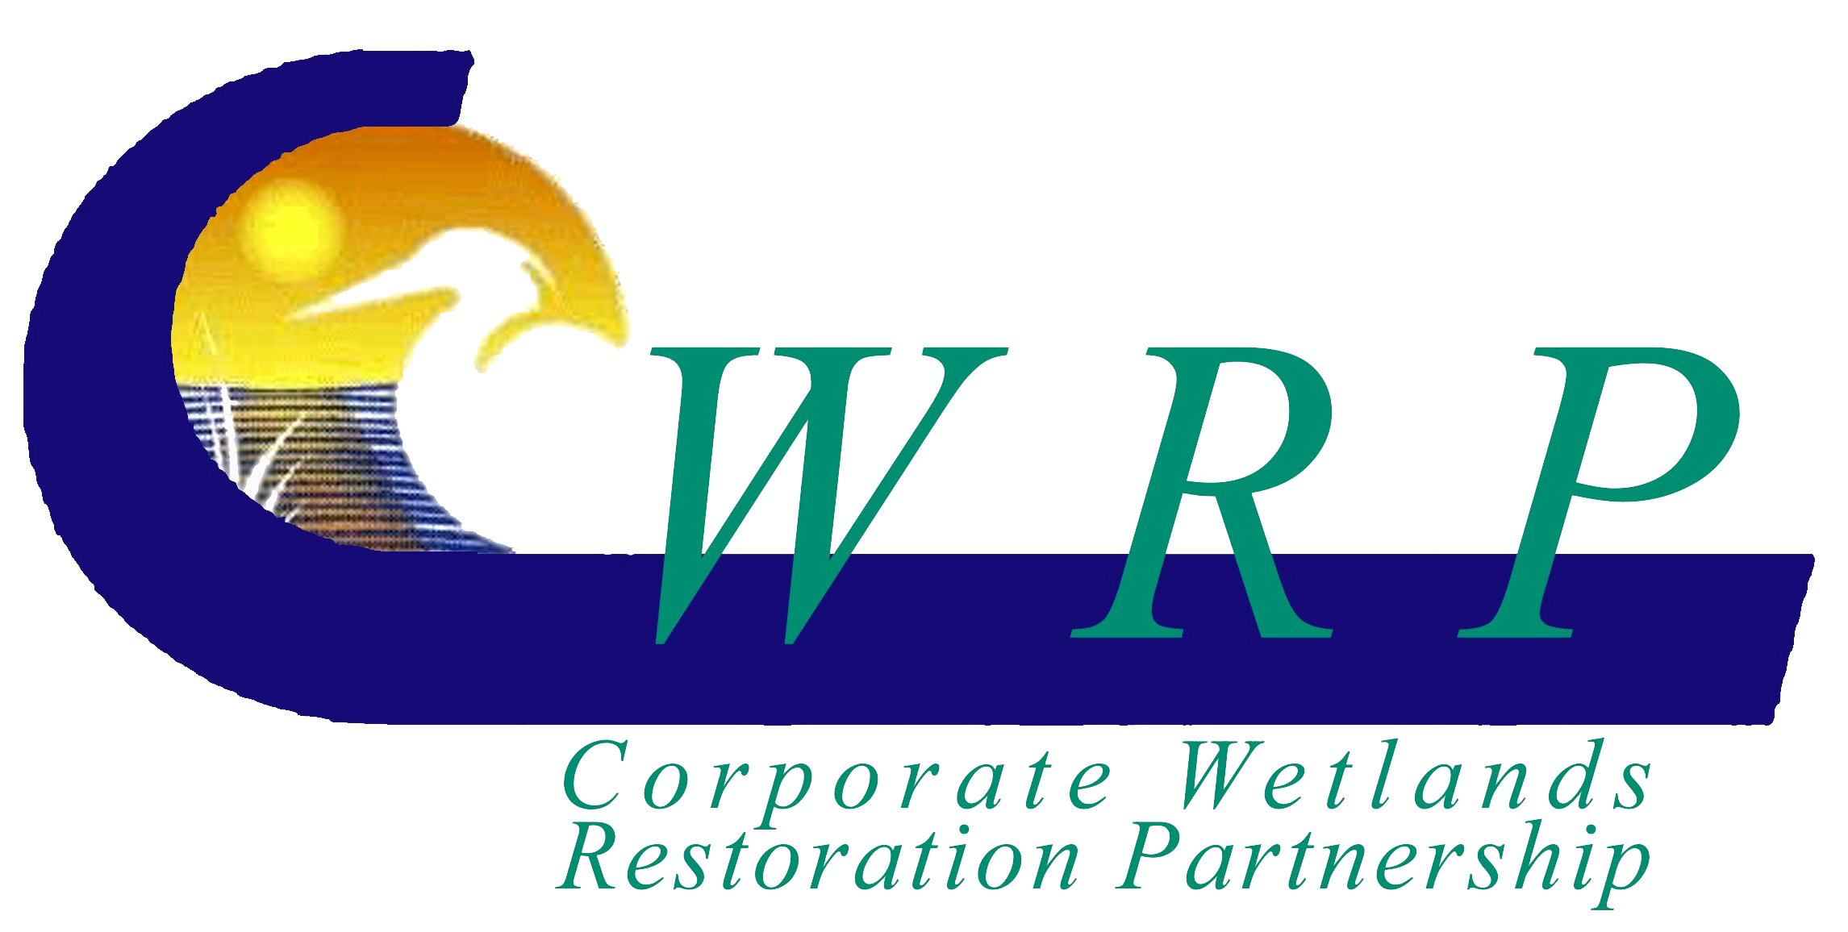 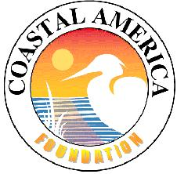

**2012 CWRP Report**

The Corporate Wetlands Restoration Partnership (CWRP), a standing committee of the Coastal America Foundation, is comprised of the National Management Subcommittee and 15 state chapters. The following report summarizes CWRP activity from 1999 through 2011 with emphasis on years 2010 and 2011. Data included in this report was obtained from state CWRP chapters and Coastal America Foundation financial records.

Since 1999 the CWRP has provided financial and in-kind services support for 308 projects and programs across the U.S. and in Canada and Mexico. With a total investment of $4,942,000 the CWRP has leveraged $114,705,000 in federal, state, and NGO funds to restore and protect 64,756 acres and 1,069 stream miles of aquatic habitat, educate 3,098 student and teachers, and attract 810 project volunteers. In addition, corporate CWRP members have voluntarily invested more than 18,000 hours in managing the partnership.

The following table summarizes CWRP performance:

|  |  |  |  |
| --- | --- | --- | --- |
|  | 1999 – 2009  (10 Year Report) | 2010 -2011 | 1999 -2011 |
| Total Projects | 243 | 65 (1) | 308 (1) |
| Wetland Restoration | 99 | 6 | 105 |
| River/Stream Restoration | 66 | 6 | 72 |
| Education | 56 | 34 | 90 |
| Research | 17 | 13 | 30 |
| Species Protection | 5 | 6 | 11 |
| Total Projects Cost | $115,918,000 | $3,729,000 | $119,647,000 |
| Total CWRP Investment | $3,666,000 | $1,276,000 (2) | $4,942,000 (2) |
| CWRP Cash Investment | $2,238,000 | $1,248,000 | $3,486,000 |
| CWRP In-kind Investment | $1,428,000 | $28,000 | $1,456,000 |
| Acres Restored/Protected | 44,069 | 20,687 | 64,756 |
| Stream Miles Restored/Protected | 976 | 93 | 1,069 |
| Students& Teachers Educated | 2,588 | 510 | 3,098 |
| Project Volunteers | 810 | - | 810 |
| Volunteer Partnership Management Hours | 11,420 | 6,616 | 18,036 |

1. Includes 22 Education & Outreach projects not captured in 10 Year Report
2. Includes $689,640 spent on Education & Outreach not captured in 10 Year Report

**CWRP Project Types**

**Total Projects=308**